Computer Language Diagrams

Call & Return in a Diagram
The concept of call and return is covered by the article Call & Return. The current article only explains its expression in a diagram.

Call and return is mentioned here for completeness sake, because it is considered a form of jump. But call and return was already explained in the article Command Call in a Diagram.

Here is what a call looks like in a diagram.

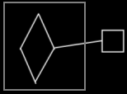

See also: Call & Return, Command Call in a Diagram

Author & Copyright: Jan-Joost van Zon Date: June 10, 2008 – June 10, 2008 Location: Oosterhout, The Netherlands Status: Finished

